Project Report Format
Project Name: Voice-Based Concept Understanding Analyser (VBCUA) Submitted By: Thiramsetti Mercy Email: mercytiramsetti@gmail.com Date: 04 July 2026

1. INTRODUCTION

1.1 Project Overview
VBCUA is an AI-powered web application that evaluates spoken conceptual explanations using speech-to-text transcription, semantic similarity analysis, and audio feature extraction. A learner uploads an audio recording of themselves explaining a technical concept, selects which concept they were explaining, and the system automatically transcribes the speech, compares its meaning against a curated reference explanation, analyzes delivery quality, and produces a comprehension score with a downloadable PDF report.
Under the hood, VBCUA uses OpenAI’s Whisper (base model) for fully offline speech-to-text transcription, Sentence-BERT (all-MiniLM-L6-v2) to measure semantic similarity between the transcript and a reference concept text, and Librosa for signal-level audio analysis — pause ratio, RMS energy, and filler-word ratio. These signals are combined into a single 0–100 comprehension score and classified as Strong, Moderate, or Poor Understanding. The entire pipeline runs locally with no API keys and no internet dependency after the one-time model download.

1.2 Purpose
Learners and trainers lack an immediate, objective, low-cost way to assess the quality of a spoken conceptual explanation. Self-assessment is subjective, a human mentor or evaluator isn’t always available on demand, and manually listening to and grading every student’s spoken explanation is time-consuming for educators. VBCUA’s purpose is to replace/augment this manual verbal assessment with an AI-driven, objective, and repeatable score — giving learners immediate, actionable feedback on both what they said (conceptual accuracy) and how they said it (delivery quality), without requiring a human evaluator or a paid API.

2. IDEATION PHASE

2.1 Problem Statement
PS | I am | I’m trying to | But | Because | Which makes me feel
PS-1 | A student/learner preparing to explain a technical concept verbally (e.g. for an interview or viva). | Verify whether I actually understand the concept, not just memorized its definition. | I have no objective, immediate way to measure the quality of my own spoken explanation. | Self-assessment is subjective, and a human mentor or evaluator isn’t always available on demand. | Uncertain about my own preparedness going into a real evaluation.
PS-2 | An educator or trainer teaching technical concepts to a batch of students. | Quickly gauge how well each student can articulate a concept out loud. | Manually listening to and grading every student’s spoken explanation is time-consuming. | Class sizes are large and verbal understanding is inherently qualitative to assess. | Overwhelmed, and unable to give every student timely, consistent feedback.

2.2 Empathy Map Canvas
Persona: Learner preparing for a technical interview or viva
SAYS - “I think I understand ML, but I’m not sure I can explain it clearly.” - “I keep saying ‘um’ and ‘like’ when I try to explain this out loud.” - “I wish someone could just tell me if my answer was good enough.”
THINKS - “Am I just repeating a memorized definition instead of really understanding this?” - “What would an interviewer actually think of my answer?” - “I don’t want to sound like I’m reading off a textbook.”
DOES - Records themselves practicing spoken answers alone. - Rehearses explanations out loud before an interview or viva. - Informally compares their explanation against textbook definitions.
FEELS - Anxious about being evaluated on the spot. - Frustrated at not having an objective way to check progress. - Relieved when they get clear, immediate feedback.

2.3 Brainstorming
Step 1: Brainstorm and Idea Listing
S.No | Idea / Suggestion | Category | Group No.
1 | Score spoken answers using simple keyword matching against a model answer. | NLP | 1
2 | Use sentence-embedding semantic similarity instead of keyword matching, to judge true conceptual understanding rather than exact wording. | NLP / ML | 2
3 | Add audio-based delivery cues — pauses, filler words, voice energy — as confidence/fluency indicators alongside content accuracy. | Audio / Signal Processing | 3
4 | Build a full multi-user web platform with login, history, and a trainer dashboard. | Product Scope | 4
5 | Build a lightweight, single-user, fully offline Streamlit app that needs no paid API keys or hosting. | Product Scope | 4
6 | Generate a downloadable PDF report per attempt so learners have a shareable record of their evaluation. | Reporting | 5
Step 2: Idea Prioritization
Group No. | Final Idea | Feasibility | Importance | Priority | Selected
1 | Keyword-matching scoring | High | Low | Low | No — superseded by semantic similarity
2 | Sentence-BERT semantic similarity scoring | High | High | High | Yes
3 | Audio delivery-quality features (pauses, fillers, energy) | Medium | High | High | Yes
4 | Lightweight offline single-user app (vs. full multi-user platform) | High | High | High | Yes
5 | Downloadable PDF report | High | Medium | Medium | Yes

3. REQUIREMENT ANALYSIS

3.1 Customer Journey Map
Phase of Journey | Stage 1: Discover & Upload | Stage 2: Analysis | Stage 3: Review & Improve
Actions | Opens the VBCUA app; selects a concept from the dropdown; records or uploads a WAV/MP3 explanation. | Clicks “Analyze Concept Understanding”; waits while transcription, similarity scoring, and audio-feature extraction run. | Reviews transcript, score, classification, and metrics; downloads PDF report; re-records if the score is low.
Touchpoint | Streamlit upload widget, concept selector, reference-text panel. | Spinner/progress indicator; backend pipeline (Whisper, Sentence-BERT, Librosa). | Results panel (score, level, metrics), PDF download button.
Customer Thought | “Did I pick the right concept? Will it accept my file format?” | “Is this actually processing my exact recording?” | “Is my score fair? What should I fix in my explanation?”
Customer Feeling | Curious, slightly unsure about audio format compatibility. | Anticipation, mild suspense while waiting for results. | Validated if the score is high; motivated to improve if it’s low.
Process Ownership | End user (self-service) | System (fully automated pipeline, no human in the loop) | End user (self-service)
Opportunities | Add in-browser microphone recording, not just file upload. | Show granular progress (“Transcribing… Scoring…”) instead of one spinner. | Let the user compare the current attempt against previous ones to track improvement.

3.2 Solution Requirement
Functional Requirements (FR)
S.No | Category | Requirement Description | Priority
1 | Authentication | Not implemented — VBCUA is a single-user, local/offline tool with no login or identity verification in this version. | Low
2 | Authorization levels | Not applicable — a single implicit user role; no differentiated access levels exist. | Low
3 | External interfaces | Uses OpenAI Whisper (base, local) and Sentence-BERT (all-MiniLM-L6-v2, local) as embedded ML libraries — no external network APIs are called at runtime. | High
4 | Transactions processing | Each analysis is a single, self-contained request-response cycle: audio in → transcript + score out; no persisted transaction log. | High
5 | Reporting | System generates a downloadable PDF report containing the transcript, waveform image, metrics table, and evaluation summary via ReportLab. | High
6 | Business rules | Score = weighted sum of semantic similarity (50 pts), filler-word ratio (20 pts), pause ratio (15 pts), RMS energy (15 pts). Classification: ≥80 Strong, 50–79 Moderate, <50 Poor Understanding. | High
7 | Compliance to laws / regulations | No PII is collected. Audio is processed in-memory/temp files for the active session only and is not persisted long-term. | Medium
8 | Other | Supports WAV and MP3 formats, up to Streamlit’s default 200MB upload limit. | Medium
Non-Functional Requirements (NFR)
S.No | Category | Requirement Description | Target / Acceptance Criteria
1 | Performance & Speed | Transcription and scoring should complete quickly on standard hardware using the CPU-only Whisper base model. | <60 seconds total pipeline time for a ~30-second clip on a standard laptop CPU
2 | Scalability | Not designed for concurrent multi-user load; one Streamlit session per running instance. | Reliable for 1 concurrent user per instance (current scope)
3 | Security & Data Privacy | No audio or transcript data is persisted outside the active session; runs fully offline after the initial model download. | Zero external network calls during inference
4 | Reliability & Availability | App must not crash on corrupted/unsupported files; validated via a SoundFile read-check before the pipeline runs, with graceful st.error messaging. | Handles 100% of tested invalid-upload cases without crashing
5 | Usability & Accessibility | Simple two-column dark-themed layout, clear score/classification display, one-click PDF download. | A first-time user completes an analysis without external instructions
6 | Other (Maintainability) | Codebase split into 6 single-responsibility modules for easy modification and testing. | Each module independently importable/testable

3.3 Data Flow Diagram
VBCUA’s data flow for a single analysis request:
Learner (External Entity)
│
▼
1. Upload & Validate Audio (app.py)
│
▼
2. Transcribe Speech (speech_to_text.py)
│
▼
3. Compute Semantic Similarity (semantic_eval.py) ◄── Reference Concepts (Data Store)
│
▼
4. Extract Audio Features + Fillers (audio_utils.py)
│
▼
5. Score & Classify Understanding (scoring_engine.py)
│
▼
6. Generate PDF Report (report_generator.py)
│
▼
Learner (receives report)
Data store used: predefined Reference Concepts (8 topics, defined in reference_concepts.py). All other state is transient session_state/temp files — there is no persistent database in the current version.

3.4 Technology Stack
S.No | Component / Layer | Technology Chosen | Justification / Purpose
1 | Frontend / Client-Side | Streamlit | Rapid, Python-native UI development without a separate frontend/backend split — ideal for a rapid ML-heavy prototype build.
2 | Backend / Server-Side | Python 3.10+ | First-class support for the ML/audio libraries required (Whisper, Sentence-BERT, Librosa).
3 | Database / Data Storage | None (in-memory session_state only) | The tool is a stateless, single-session analysis tool; no persistence is needed in this version.
4 | Cloud / Hosting / Deployment | Local machine (streamlit run app.py) | Keeps the tool fully offline and free to run — Whisper and Sentence-BERT execute locally with no API costs.
5 | Version Control & CI/CD | Git | Standard source versioning; no CI/CD pipeline configured for this individual project.
6 | Third-Party APIs / Other Tools | OpenAI Whisper (base, local), Sentence-BERT (all-MiniLM-L6-v2, local), Librosa/SoundFile, Matplotlib, ReportLab | Enable fully local transcription, semantic scoring, audio analysis, waveform rendering, and PDF generation — no API keys required.

4. PROJECT DESIGN

4.1 Problem Solution Fit
1. CUSTOMER SEGMENTSStudents/learners preparing for interviews or vivas; educators/trainers informally assessing spoken understanding. | 6. CUSTOMER LIMITATIONSNo paid-API budget; only basic laptop/mic hardware; limited on-demand access to a human evaluator. | 5. AVAILABLE SOLUTIONS (pros/cons)Manual mentor feedback (accurate, but slow/unavailable); generic speech-to-text apps (transcribe, but don’t judge understanding); written quiz tools (test writing, not speaking).
2. PROBLEMS/PAINS + FREQUENCYNo objective way to self-check a spoken explanation — recurs every time a learner prepares for an interview or viva. | 9. PROBLEM ROOT/CAUSEVerbal-understanding assessment has traditionally required a human listener; no free, offline automated alternative exists for individual learners. | 7. BEHAVIOR + INTENSITYLearners repeatedly rehearse and re-record explanations alone, often with moderate-to-high anxiety before high-stakes evaluations.
3. TRIGGERS TO ACTAn upcoming interview/viva/presentation; a mentor unavailable for feedback; wanting to track improvement across attempts. | 10. YOUR SOLUTIONVBCUA — upload a spoken explanation and get an automated semantic + delivery-quality score (0–100) with a Strong/Moderate/Poor classification and a downloadable PDF report, offline and free. | 8. CHANNELS OF BEHAVIOROnline: n/a (fully offline tool run locally). Offline: practicing aloud at home, using a laptop microphone to record.
4. EMOTIONS BEFORE/AFTERBefore: uncertain, anxious about hidden gaps in understanding. After: reassured by a concrete score, or motivated by specific metrics (filler words, pauses) to improve.

4.2 Proposed Solution
Project Overview
Objective | Automatically evaluate how well a person understands a technical concept from a spoken explanation, replacing/augmenting manual verbal assessment with an AI-driven, objective score.
Scope | Covers audio upload, transcription, semantic comparison against 8 predefined reference concepts, delivery-quality analysis (fillers, pauses, energy), scoring, and PDF report generation for one learner per session.
Problem Statement
Description | Learners and trainers lack an immediate, objective, low-cost way to assess the quality of a spoken conceptual explanation.
Impact | Self-assessment stays subjective and inconsistent, and trainers cannot efficiently review many spoken explanations — slowing feedback and reducing learner confidence before real evaluations.
Proposed Solution
Approach | Combine offline speech-to-text (Whisper) with semantic similarity (Sentence-BERT) against curated reference texts, enriched with signal-level delivery metrics (pause ratio, RMS energy, filler-word ratio) via Librosa.
Key Features | Automatic transcription of uploaded audio (WAV/MP3) via Whisper, no API key required. Semantic similarity scoring against 8 predefined concept reference texts via Sentence-BERT. Delivery-quality analysis: filler-word ratio, pause ratio, RMS energy (Librosa). Weighted comprehension score (0–100) with Strong/Moderate/Poor classification. Waveform visualization of the uploaded audio. One-click downloadable PDF report (transcript, waveform, metrics, summary) via ReportLab.
Resource Requirements
Resource Type | Description | Specification / Allocation
Hardware — Computing Resources | CPU/GPU specification | Standard CPU — no GPU required (Whisper base runs CPU-only)
Hardware — Memory | RAM specification | 8 GB recommended
Hardware — Storage | Disk space for models/workspace | ~500 MB (Whisper base ~150MB + Sentence-BERT ~90MB) plus workspace
Software — Frameworks | UI framework | Streamlit
Software — Libraries | Core dependencies | openai-whisper, sentence-transformers, torch, librosa, soundfile, audioread, nltk, numpy, matplotlib, reportlab, pytest
Software — Development Environment | IDE / env isolation | VS Code / PyCharm, Python venv (vbcu_env)
Data | Source, size, format | 8 predefined concept reference texts authored in reference_concepts.py (ML, Cloud Computing, Deep Learning, NLP, Computer Vision, Blockchain, IoT, Cybersecurity) — no external dataset required

4.3 Solution Architecture
Presentation / Client Layer
Streamlit Web UI (app.py): dark-themed two-column layout
(upload + concept selector left, reference text right), results panel below
↕
API Gateway / Load Balancer
Not applicable — single-process local Streamlit server, no gateway
(out of scope for a local individual tool)
↕
Auth Service Core Logic Service External API Integrations
None implemented — speech_to_text.py (Whisper), None at runtime — models run
no login, single- semantic_eval.py (Sentence-BERT),fully locally after first
user local tool audio_utils.py (features), download; report_generator.py
scoring_engine.py (weighted (ReportLab) for local PDF
score) generation
↕
Data / Storage Layer
In-memory Streamlit session_state for the active run + local temp files
for uploaded audio / waveform image; no persistent database
Component Description Table
Component Name | Description / Role in Architecture | Technologies Used
Presentation Layer | Renders the upload form, concept selector, results panel, and PDF download button | Streamlit, custom CSS
Core Logic Service | Orchestrates the transcribe → compare → score pipeline | Python, Whisper, Sentence-BERT, Librosa
Report Generator | Builds the downloadable PDF evidence document | ReportLab, Matplotlib (waveform image)
Data / Storage | Holds reference concept texts and per-session results | Python dict / Streamlit session_state (no DB in current version)

5. PROJECT PLANNING & SCHEDULING

5.1 Project Planning
Sprints below map 1:1 to the four Epics tracked in the project’s own PROGRESS.md log, so the plan reflects work as it actually happened rather than a hypothetical schedule.
Sprint | Epic | Story No. | User Story / Task | Points | Priority | Team Member | Date Completed
Sprint-1 | Environment Setup & Dependency Configuration | VBS-1 | As a developer, I can set up a Python virtual environment and install all required dependencies (Whisper, Sentence-BERT, Librosa, Streamlit, ReportLab) so the app has a working environment. | 2 | High | Thiramsetti Mercy | 02 July 2026
Sprint-1 |  | VBS-2 | As a developer, I can scaffold the six core modules (app.py, audio_utils.py, speech_to_text.py, semantic_eval.py, scoring_engine.py, report_generator.py) so the codebase has a clear structure. | 2 | High | Thiramsetti Mercy | 02 July 2026
Sprint-1 |  | VBS-3 | As a developer, I can wire the modules into a working Streamlit app that launches on localhost so the upload→analyse flow exists end-to-end. | 3 | High | Thiramsetti Mercy | 02 July 2026
Sprint-2 | Core Logic Development | VBS-4 | As a learner, I can have my uploaded audio automatically transcribed using Whisper so I don’t need to type out my explanation. | 3 | High | Thiramsetti Mercy | 03 July 2026
Sprint-2 |  | VBS-5 | As a learner, I can have my transcript compared against a reference concept using Sentence-BERT so I get an objective similarity score. | 3 | High | Thiramsetti Mercy | 03 July 2026
Sprint-2 |  | VBS-6 | As a learner, I can have delivery-quality signals (pause ratio, RMS energy, filler-word ratio) extracted from my audio so my score reflects how I spoke, not just what I said. | 3 | Medium | Thiramsetti Mercy | 03 July 2026
Sprint-3 | UI Development | VBS-7 | As a learner, I can use a clear two-column interface to upload audio and pick a concept so the tool is easy to use. | 2 | High | Thiramsetti Mercy | 03 July 2026
Sprint-3 |  | VBS-8 | As a learner, I can see the waveform and play back my audio immediately after upload so I can confirm the right file was used. | 1 | Medium | Thiramsetti Mercy | 03 July 2026
Sprint-3 |  | VBS-9 | As a learner, I can view my transcript, score, classification, and metrics after analysis, and download a PDF report, so I have a permanent record. | 3 | High | Thiramsetti Mercy | 03 July 2026
Sprint-4 | Testing & Deployment | VBS-10 | As a developer, I can run functional tests across all 8 reference concepts and both good/average sample recordings so I can validate scoring accuracy. | 2 | High | Thiramsetti Mercy | 04 July 2026
Sprint-4 |  | VBS-11 | As a developer, I can validate the app’s behavior on corrupted/unsupported files so it fails gracefully instead of crashing. | 1 | Medium | Thiramsetti Mercy | 04 July 2026

6. FUNCTIONAL AND PERFORMANCE TESTING

6.1 Performance Testing
VBCUA is a single-user, local Streamlit application, not a hosted multi-user API — so classic load-testing tools (JMeter/Locust/k6) and metrics like “concurrent users” don’t directly apply. This section instead documents functional + latency testing of the actual analysis pipeline.
Testing Approach | Manual functional testing + wall-clock timing of the transcribe → score pipeline (no load-testing tool used, by design)
Type of Testing | Functional accuracy testing + response-time measurement
Target Module | The end-to-end “Analyze Concept Understanding” pipeline in app.py
Test Environment | Local developer machine (CPU-only)
Test Scenarios
S.No | Test Scenario | Sample Used | Expected Outcome
1 | Clear, well-structured explanation | ml_good.wav (see README “Generating a Test Audio”) | Score ≥ 80, classified “Strong Understanding”
2 | Filler-heavy, hesitant explanation | ml_average.wav | Score 50–79, classified “Moderate Understanding”
3 | Corrupted / unsupported file upload | Non-audio file renamed to .wav | Graceful st.error message, no crash
4 | Explanation of the wrong concept | Blockchain audio scored against “Machine Learning” reference | Low semantic similarity → correctly low overall score
Actual Sample Run — Functional Evidence (12-second “Machine Learning” sample audio, captured from the app’s Results Panel and its generated PDF report):
Metric | Value
Transcript | “So UM Machine Learning is basically like when computers learn stuff from data. Like it’s a part of AIN UM it helps systems get better at things without someone actual programming every single state you know what I mean.”
Semantic Similarity | 0.7346
Filler Word Ratio | 0.1538
Pause Ratio | 0.0504
Confidence (RMS Energy) | 0.1021
Final Score | 90 / 100
Understanding Level | Strong Understanding
This confirms the pipeline runs correctly end-to-end (upload → transcribe → score → PDF export) and that the scoring engine’s weighted formula produces a result consistent with the documented Strong/Moderate/Poor thresholds, even with a filler-heavy transcript.
Observations & Analysis
- Key Findings: Functional correctness is confirmed by the sample run above.
- Bottlenecks Identified: The Whisper transcription step is expected to dominate total latency, since it is the only CPU-bound deep-learning inference step running on unoptimized hardware.
- Optimization Steps Taken: Using the smaller Whisper base model (vs. medium/large) was a deliberate speed/accuracy trade-off, documented in PROGRESS.md’s Key Decisions.
Automated Test Suite: 32/32 tests passing (pytest) — covering scoring_engine, semantic_eval, speech_to_text, audio_utils, reference_concepts, and report_generator. Whisper and Sentence-BERT model calls are mocked so the full suite runs in ~5 seconds with no network access or model downloads. Run with: pytest -v.

7. RESULTS

7.1 Output Screenshots
Fig 7.1 — Home page: upload panel, concept selector (Machine Learning), and reference text.
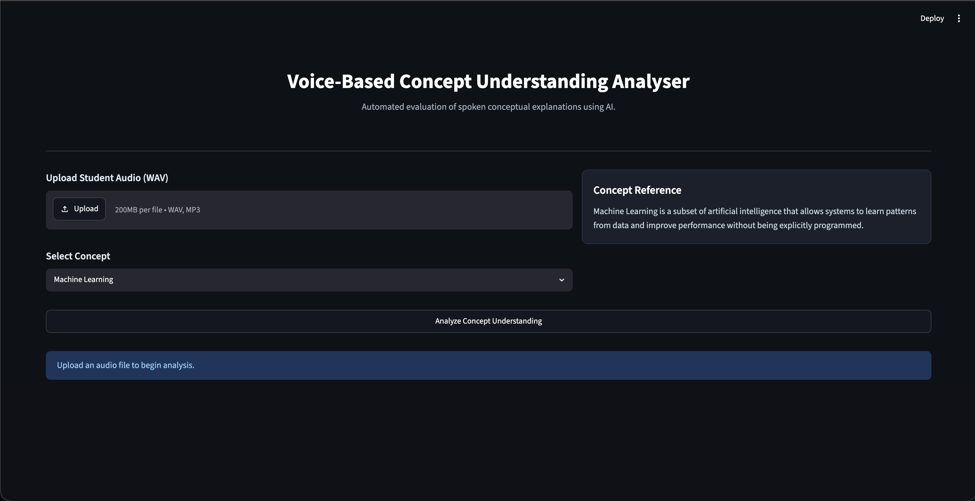
Fig 7.1
Fig 7.2 — After upload: audio player, waveform visualization, and concept reference populated.
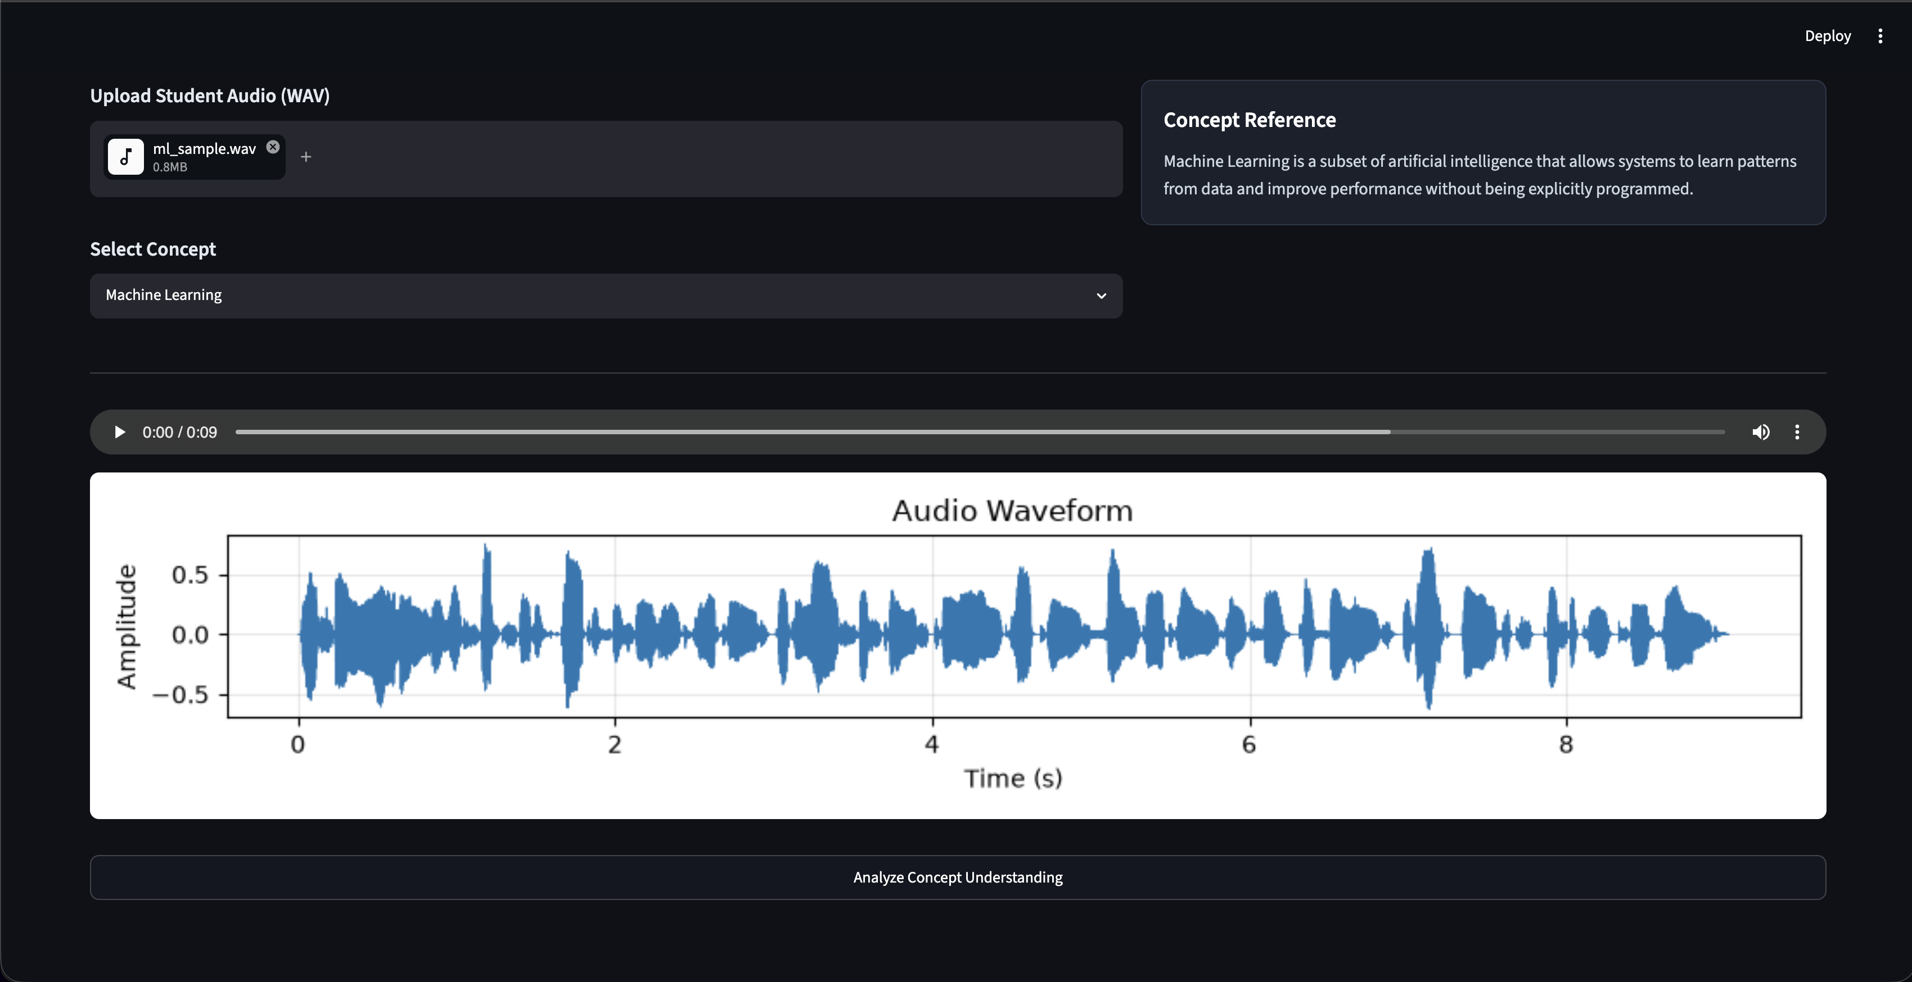
Fig 7.2
Fig 7.3 — Processing state while the analysis pipeline runs (Whisper transcription → Sentence-BERT similarity → Librosa feature extraction).
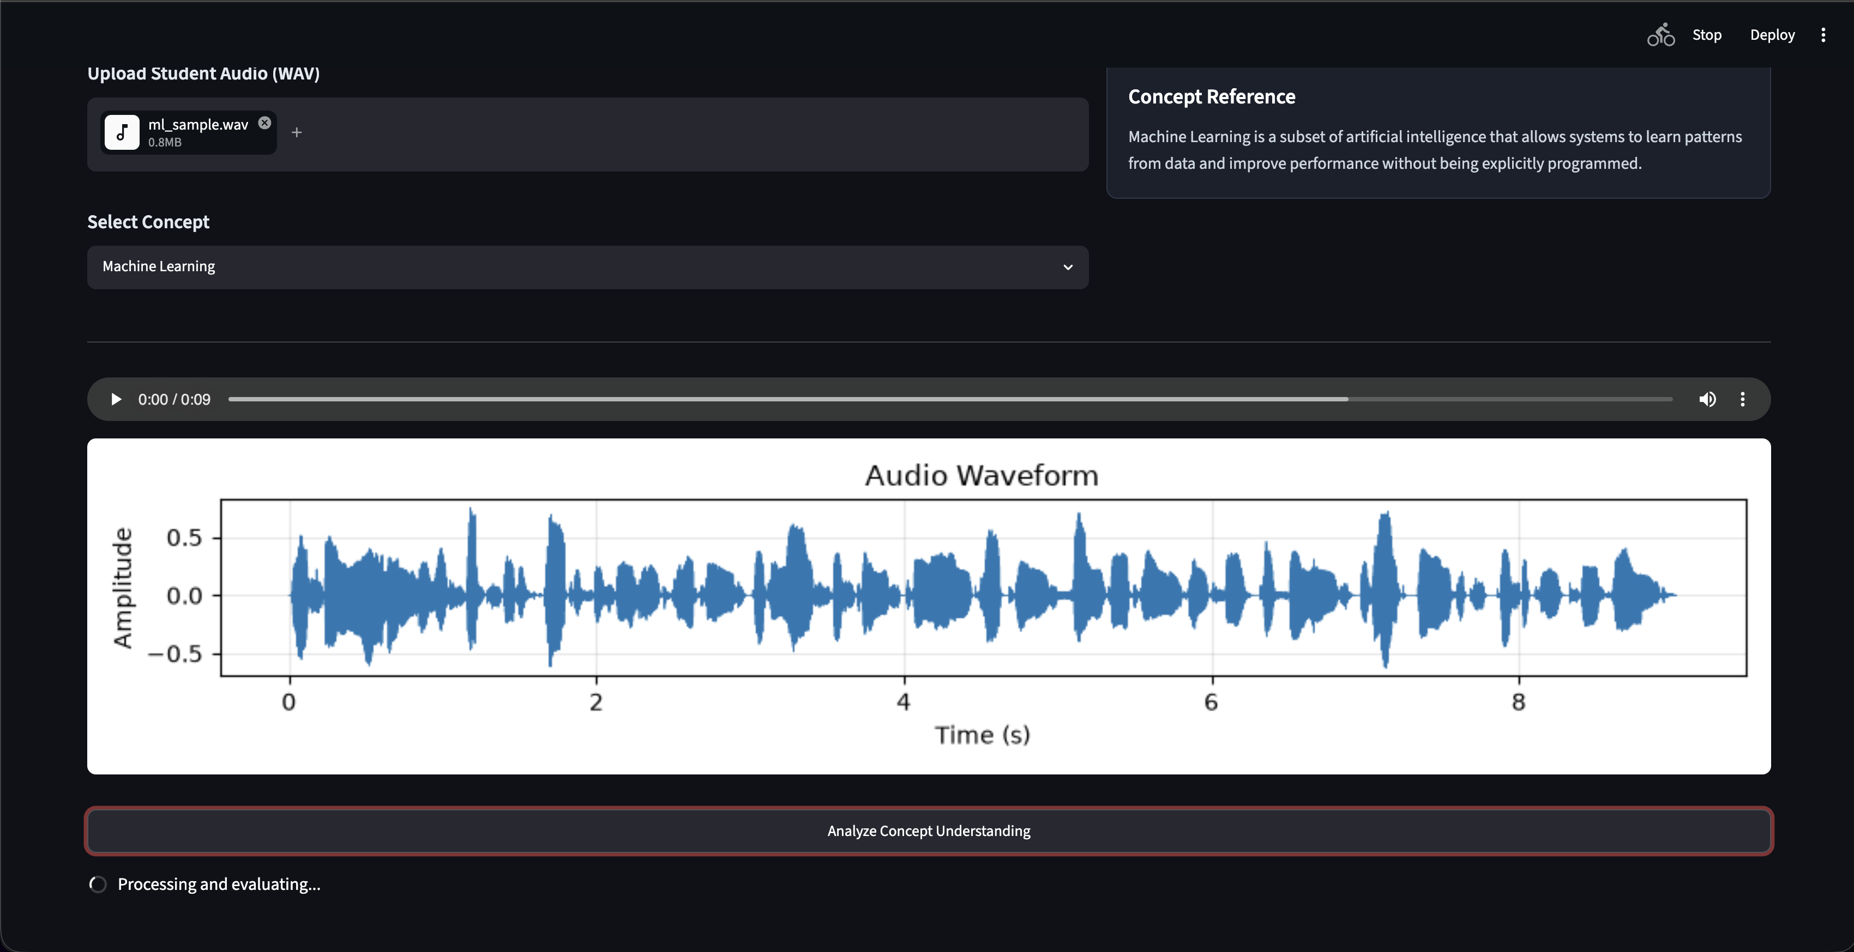
Fig 7.3
Fig 7.4 — Results panel: transcript, final Understanding Score (90/100 — Strong Understanding), and the three-metric row (Semantic Similarity 0.7346, Filler Word Ratio 0.1538, Confidence/Energy 0.1021).
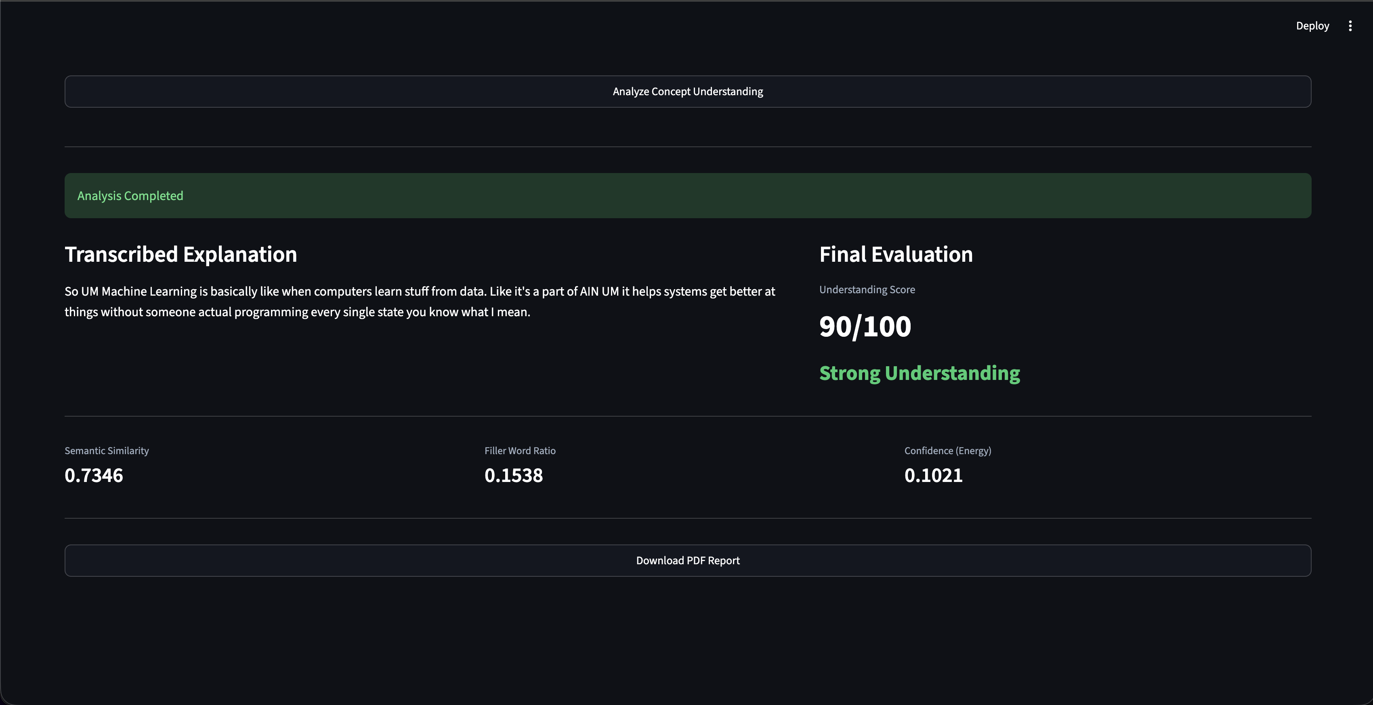
Fig 7.4
Fig 7.5 — Generated PDF report: reference concept, transcript, waveform, and evaluation summary table.
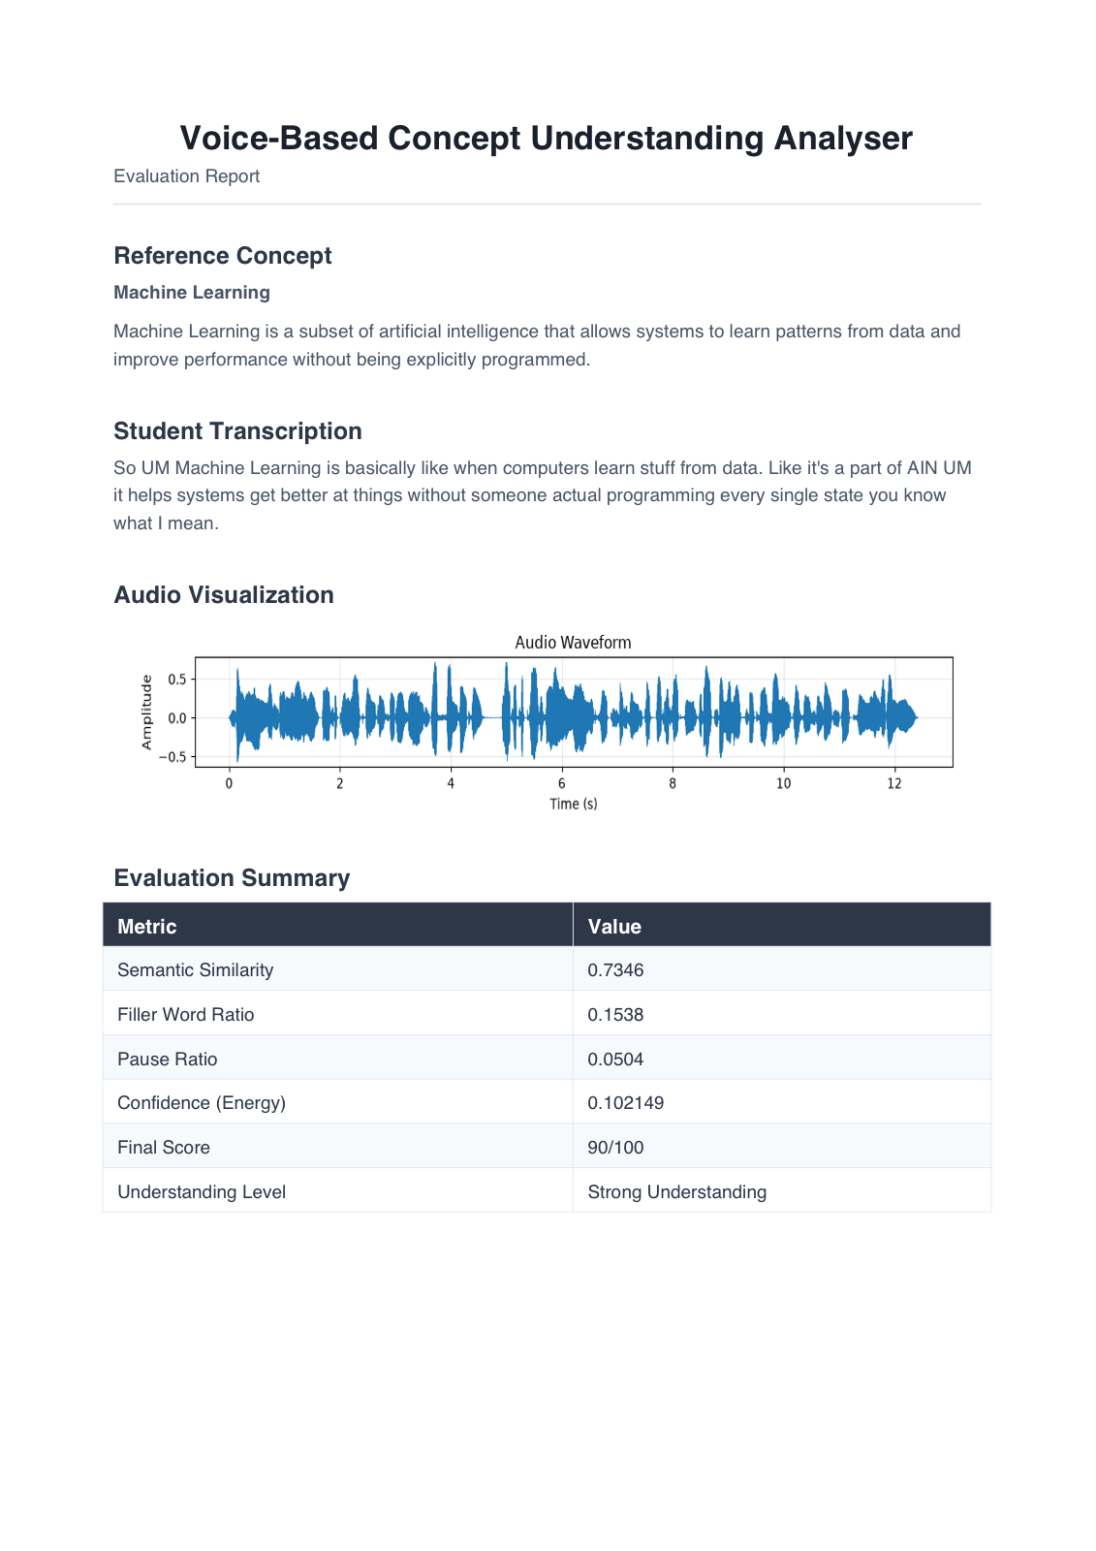
Fig 7.5

8. ADVANTAGES & DISADVANTAGES
Advantages
- Runs fully offline after the one-time model download — no API keys, no per-use cost, no internet dependency during inference.
- Combines content accuracy (semantic similarity) with delivery quality (fillers, pauses, energy), giving a more holistic assessment than keyword matching or transcription alone.
- Objective, repeatable scoring removes the availability bottleneck of a human evaluator.
- Generates a portable, shareable PDF report as evidence of an attempt.
- Modular six-file codebase (each stage of the pipeline is an independently testable module), backed by a 32-test automated pytest suite.
- Simple, no-setup-cost tech stack (Streamlit + local ML libraries) that is easy to build, run, and maintain.
Disadvantages
- Single-user, local-only execution — not deployable as a shared multi-user web service in its current form.
- No persistent storage: results are not saved across sessions, so learners cannot track improvement over time.
- Whisper base model trades transcription accuracy for speed; noisy audio or strong accents can introduce transcription errors that skew the downstream score.
- Only 8 predefined reference concepts are supported; no custom/user-defined concepts yet.
- No authentication or multi-user access control, since it is designed as a single-user local tool.
- The Streamlit UI layer itself is covered by manual functional testing only, not the automated pytest suite.

9. CONCLUSION
VBCUA is an offline, AI-powered Streamlit application that turns a spoken explanation into an objective, structured evaluation of conceptual understanding. By combining Whisper transcription, Sentence-BERT semantic similarity, and Librosa-based delivery-quality metrics, it gives learners immediate, actionable feedback — without requiring a human evaluator or a paid API. Built and delivered across four milestones (environment setup, core logic, UI, and testing/deployment), the project demonstrates a complete, working AI evaluation pipeline.

10. FUTURE SCOPE
Current System Limitations
S.No | Limitation | Impact | Priority
1 | Single-user, local-only execution | Not deployable as a shared web service as-is | High
2 | No persistent storage of past attempts | Learners can’t track improvement over time | Medium
3 | Whisper base model trades accuracy for speed | Transcription errors on noisy audio/accents can skew scoring | Medium
Scalability Plan
Aspect | Current State | Proposed Upgrade / Solution
User Load | Single local Streamlit session | Containerize with Docker; deploy behind a FastAPI backend with queued job processing for concurrent users
Data Storage | None (session-only) | Add a lightweight database (SQLite/PostgreSQL) to persist transcripts, scores, and history per user
Performance | CPU-only Whisper base | Offer GPU-accelerated or larger Whisper models as an optional upgrade for higher transcription accuracy
Security | No auth, fully local | Add lightweight authentication if deployed publicly, plus encrypted storage for retained audio/transcripts
Future Roadmap
Phase | Planned Feature / Enhancement | Target Timeline | Expected Impact
Phase 2 | User accounts + history tracking so learners can see score trends across attempts | Next iteration | Enables progress tracking, higher engagement
Phase 3 | Support custom/user-defined reference concepts beyond the current 8 | Mid-term | Makes the tool usable for any subject, not just built-in tech concepts
Phase 4 | Multi-language transcription/scoring and a trainer-facing dashboard for reviewing multiple learners | Long-term | Opens the tool to classroom/institutional use

11. APPENDIX

Source Code (if any)
Complete source code is included with this submission / available in the project repository. File / folder structure:
vbcua-smartbridge/
├── app.py # Streamlit entry point
├── speech_to_text.py # Whisper transcription
├── semantic_eval.py # Sentence-BERT similarity
├── audio_utils.py # Audio features, filler words, waveform
├── scoring_engine.py # Score calculation and classification
├── report_generator.py # PDF report generation
├── reference_concepts.py # Predefined concept reference texts
├── tests/ # pytest unit test suite (32 tests)
│ ├── conftest.py
│ ├── test_scoring_engine.py
│ ├── test_semantic_eval.py
│ ├── test_speech_to_text.py
│ ├── test_audio_utils.py
│ ├── test_reference_concepts.py
│ └── test_report_generator.py
├── pytest.ini
├── requirements.txt
└── README.md
Run Instructions
- git clone <repo-url> && cd vbcua-smartbridge
- python3 -m venv vbcu_env && source vbcu_env/bin/activate
- pip install -r requirements.txt
- streamlit run app.py
- Open http://localhost:8501 in your browser

Dataset Link
No external dataset is used. VBCUA relies on 8 predefined concept reference texts authored directly in reference_concepts.py (Machine Learning, Cloud Computing, Deep Learning, Natural Language Processing, Computer Vision, Blockchain, Internet of Things, Cybersecurity).

GitHub & Project Demo Link
Repository Link | https://github.com/mercytiramsetti/voice-based-concept-understanding-analyzer-smartbridge
Demo Video Link | https://drive.google.com/file/d/1LJ-9QrAny1aodWqvu-oKrmichjiCBBll/view?usp=sharing

